Project Design Phase-I
Data Flow Diagram & User Stories

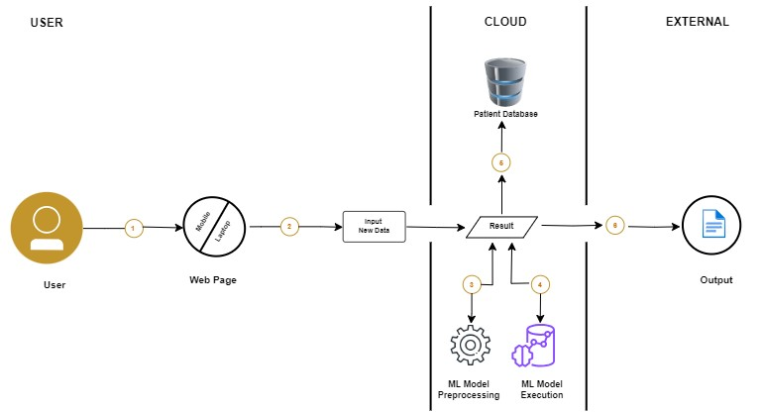
Flow:

- User Access the webpage using either mobile phone or system
- User Enter New Data points for prediction
3 & 4 ML model pre-process and execute the new data and provide prediction result
- The result is saved into Patient Database
- The prediction result shown on the screen as output

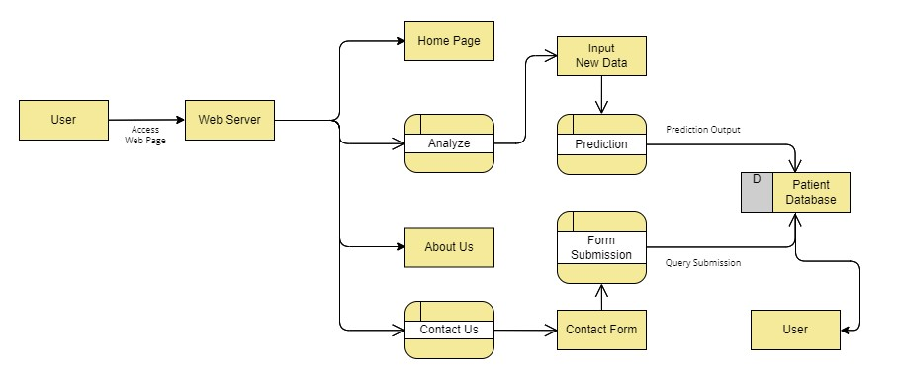
Data Flow Diagram (DFD):

User Stories

User Type | Functional  Requirement (Epic) | User  Story  Number | User Story/Task | Acceptance  Criteria | Priority | Release
User  (Mobile user) | Webpage | USN-1 | Analyse/Predict for new data | All fields should be filled & numeric | High | Sprint-1
 |  | USN-2 | User get Predicted output | Must be of classes (Normal,  Pathological & Suspect) | High | Sprint -1
 |  | USN-3 | User missed a field area in analyse | Empty Field | Medium | Sprint-2
 |  | USN-4 | User go to About page | Go to About Page | Low | Sprint-3
 |  | USN-5 | User go to Contact Us page | Fill the form | Low | Sprint-3
User  (Laptop/  Desktop User) | Webpage | USN-1 | Analyse/Predict for new data | All fields should be filled & numeric | High | Sprint-1
 |  | USN-2 | User get Predicted output | Must be of classes (Normal,  Pathological & Suspect) | High | Sprint -1
 |  | USN-3 | User missed a field area in analyse | Empty Field | Medium | Sprint-2
 |  | USN-4 | User go to About page | Go to About Page | Low | Sprint-3
 |  | USN-5 | User go to Contact Us page | Fill the form | Low | Sprint-3

